Book Recommendations for Beyond the Book
Title | Author | Synopsis
Forged by Fire  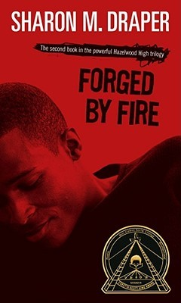 | Sharon Draper | As a teenager, Gerald finds success as a member of the Hazelwood Tigers basketball team, while Angel develops her talents as a dancer. Trouble still haunts them, however, and Gerald learns, painfully, that young friends can die and old enemies must be faced. In the end he must stand up to his stepfather alone in a blazing confrontation.
Tears of a Tiger  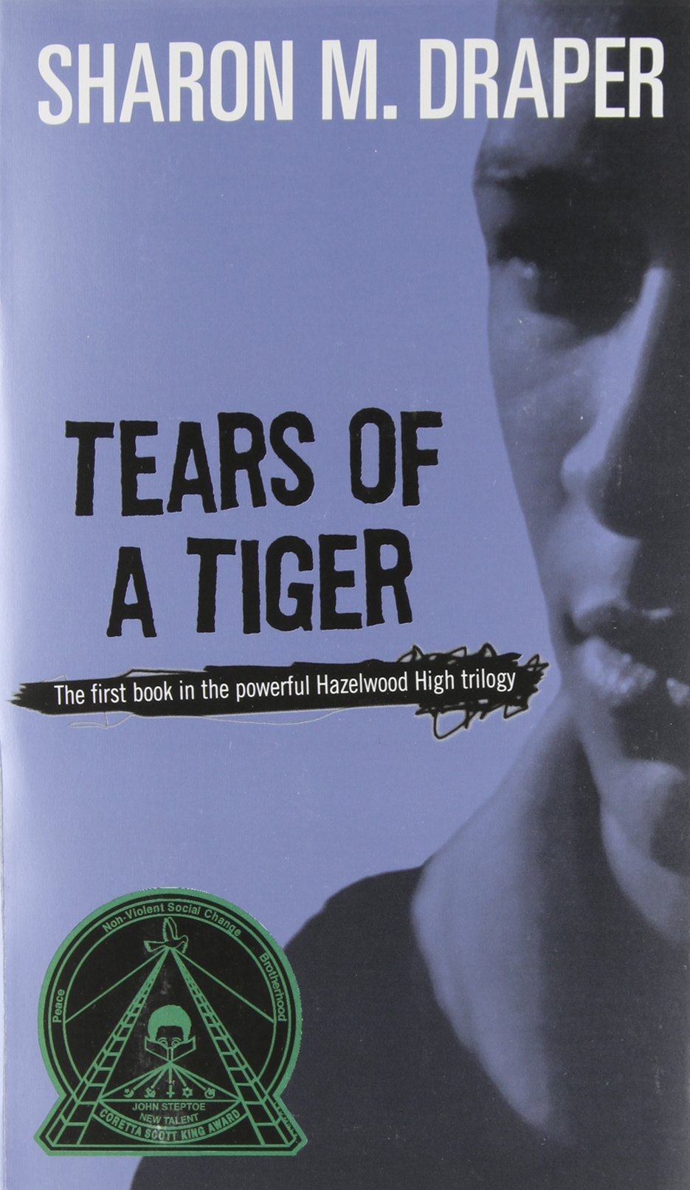 | Sharon Draper | This novel tells the story of bad teenage decisions and the consequences that follow. The novel focuses on the main character, Andy, a high school basketball player who kills his best friend Robbie in a car accident after drinking and driving one night.
Out of My Mind   | Sharon Draper | Melody Brooks is bright a ten-year old with a photographic memory who loves country music, books on tape, and her family. Melody also loves words and language, but she’s unable to speak. In this novel, she gives a history of her life, and what it has been like to grow up in silence.
Wonder  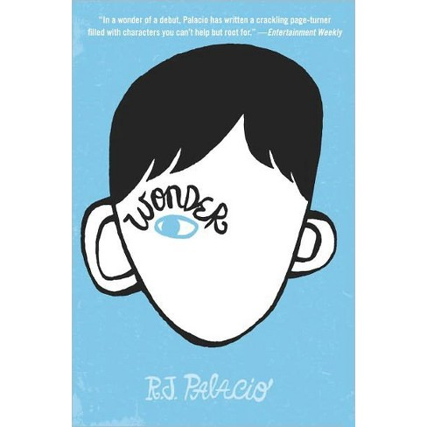 | R.J. Palacio | This New York Times bestseller tells the incredibly inspiring and heartwarming story of August Pullman, a boy with facial differences who enters fifth grade, attending a mainstream elementary school for the first time.
Long Way Down  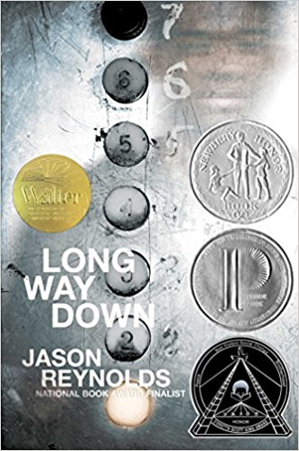 | Jeyson Reynolds | This book takes place in 60 seconds the time it takes a kid to decide if he’s going to murder the guy who killed his brother. He gets on the elevator and in seven floors meets multiple ghosts who help him makes his decision.
Ghost   | Jeyson Reynolds | Ghost follows seventh-grader Castle “Ghost” Cranshaw as he joins a track team and struggles to deal with his past and his present. Ghost has been running away from his problems his whole life, and now if he can stay on track he can be the best sprinter in the city.

